**LAB 7**

**PRE LAB:**

1. What are the techniques of Knowledge Representation? Explain in brief about Logical Representationand write the advantages and disadvantages of Logical Representation?

2. List the names of inference rules of Propositional logic and write the properties of the Propositional logic?

**IN LAB:**

1. Given below is the list of inference rules:

mammal(A) ==> vertebrate(A).

vertebrate(A) ==> animal(A).

vertebrate(A),flying(A) ==> bird(A).

vertebrate("duck").

flying("duck").

mammal("cat").

Translate those rules into a python code.

OUTPUT:

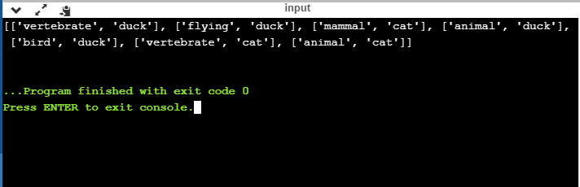

2. Solve the following

Consider the following axioms:

1. Anyone whom Mary loves is a football star.

2. Any student who does not pass does not play.

1. John is a student.

2. Any student who does not study does not pass.

3. Anyone who does not play is not a football star.

4. (Conclusion) if John does not study, then Mary does not love

John.

**POSTLAB:**

1. After teacher explained about inference topic in Proportional logic topic, Sita gave these problems to her friend to test her capability. Help her solve the problems.

i. “If I eat spicy foods, then I have strange dreams.” “I have strange dreams if there is thunder while I sleep.” “I did not have strange dreams.”

ii. “I am dreaming or hallucinating.” “I am not dreaming.” “If I am hallucinating, I see elephants running down the road.”